**Jira**

* **Jira:**

Jira is a tool that helps teams to manage project and keeps track of all the tasks Jira supports agile methods like scrum and kanban Teams use jira to organize their work into pieces and see what everyone is working on and track progress

* First we create a project in jira for whatever we are working on
* Inside the project we break the work into the smaller pieces
* We can visualize these tasks on board each column represents a stage of work like To Do ,In Progress, and Done
* As we work on the tasks we move them from one column to the next column on the board showing our progress from start to finish
* We are using scrum method then we can group task into sprints
* We can update task with progress jira helps everyone knows what’s going on
* Jira also has a reports block that helps us to see how much work is done and how much is left
* **Project overview**

1. In jira we can add more team member to a project
2. The backlog is a list of all tasks , users stories or issues that needs to be completed
3. In board we can organize and track our project task
4. Code feature option connect our project to a git repository it helps us to track changes to our projects code
5. In project pages we can keep documents,notes and other important information that everyone access on the team
6. In project setting we can customize how our project works, who can access it and whats features are available

* **Scrum in jira:**

Scrum in jira is a framework used by a team to manage their work. It helps teams to organize tasks and track the progress

1. **Backlog :**

* Backlog is a list of all features and fixed that needs to be made to the product
* In jira go to the project board there we can access the backlog by clicking on the backlog
* In the backlog we will see a list of all the tasks, user stories we can prioritize these items by dragging and dropping them
* For adding a new task we can click the create button and fill the necessary details such as summary and descriptions and then click create to add it to the backlog
* We can use story points to analyze how long it will take to complete each task

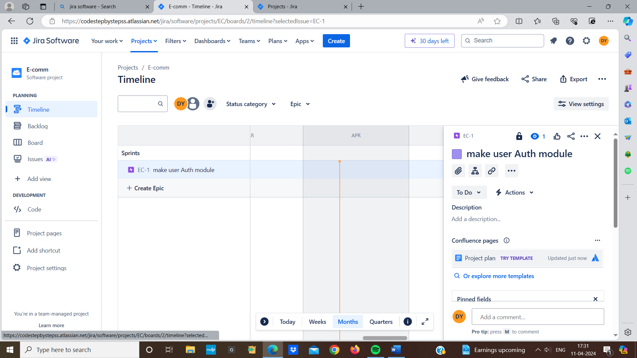

1. **Sprint planning:** In the sprint planning the team selects a set of features from the product to work on team break these items into smaller tasks
2. **Sprint:**

* In sprint we decide what work we want to complete in the next sprint
* In jira go to our project board and navigate to the sprint from there we can create a new sprint
* Once sprint is created add tasks that we want to work on during the sprint
* During the sprint our team will work on completing the tasks that we have added to the sprint
* We work on tasks we can update their status in jira to check progress

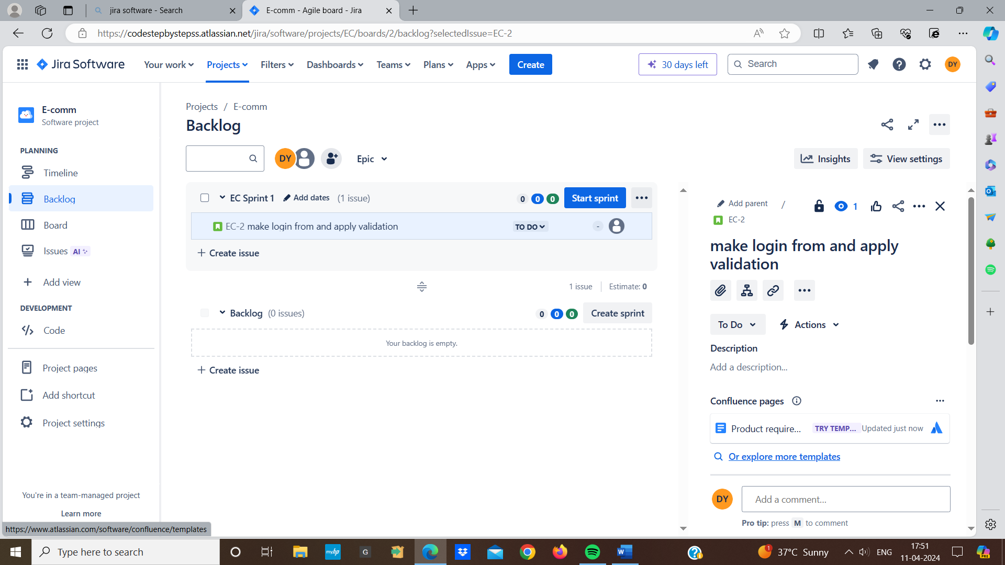

1. **Epic :**

* An epic is a large body of work that can be broken down into smaller tasks within a project
* To create an epic go to our project in jira and click create epic and fill in details such as name , summary, and description
* Once epic is created we can start adding issues to it and when editing an issue we can link it to an epic using epic link field
* Epics are useful for tracking the progress jira allows us to see how many issues in the epic and how many are done and how many are pending

**5. Story :**

* Story represent a piece of work that needs to be done to complete a work
* Each story is broken down into smaller tasks that needs to be completed
* Teams analyze how much effort each story will require to complete
* To create a story we click on the create button and select story as the issue type
* Then we fill in the details of the story such as summary and description
* Once the story is created we can add more details
* Breakdown the story into the smaller tasks

* **Bugs issues in jira:**
* Bug is type of issue used to track problem in a software application when a users encounters an issue such as feature not working as expected or an error message appearing they can report it as a bug in jira
* We create a new bug issue in jira and provide details about the issues such as description , steps to reproduce and any relevant screenshot
* Assign the bug to the developers
* They fix the issue and any changed the code
* Once the bug is fixed the bug is closed
* **Create task in jira:**

**Task :**

* Task represents a piece of work that needs to be completed
* Tasks focus on the technical implementations details
* To create a task we click on create button and select task as the issue type and fill in the details for task such as summary, description and assign
* Click create to create the task

**Task options:** when creating a task we can customize various options such as

1. Assign - the person responsible for completing the task
2. Due date - the deadline for completing the task
3. Labels - tags to get the task
4. Attachments- attach files or documents
5. Description- additional details for the task

* **Search in jira :**

**Board search :**

* Board in jira represent a set of issue organized based on their status
* Find the board and look for a search bar at the top of the board block
* Enter the search query into the search bar we can search for issues based on keywords , issues , labels
* The board will display the search results

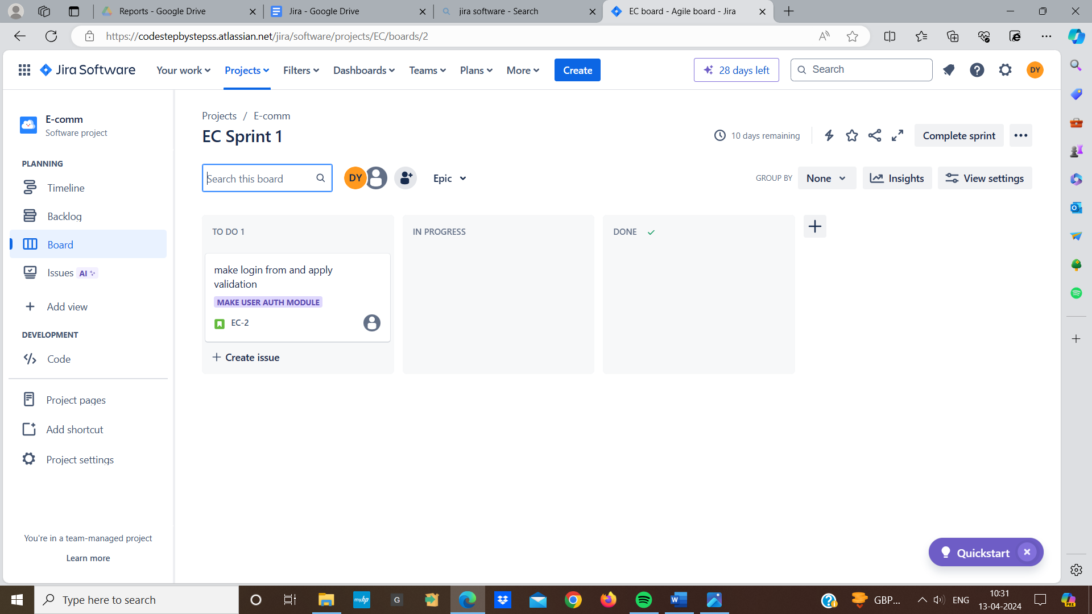

**Global search:**

* To searching within a specific project we can also use global search across all project in jira
* Global search allows us to find issues projects or information from anywhere with jira instance

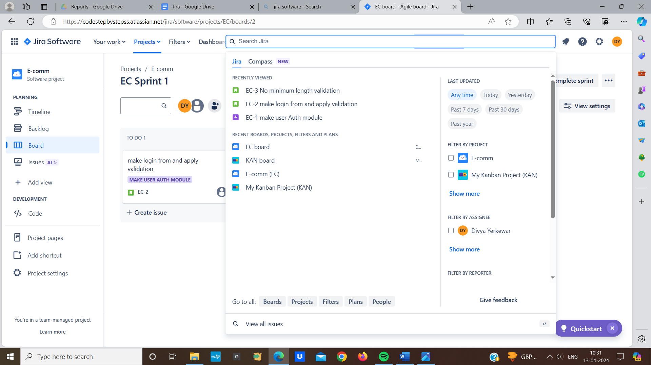

**Basic issue search:**

* We can perform a basic search by entering keyword into the issue search bar
* Jira will return a list of relevant issues that match the search query

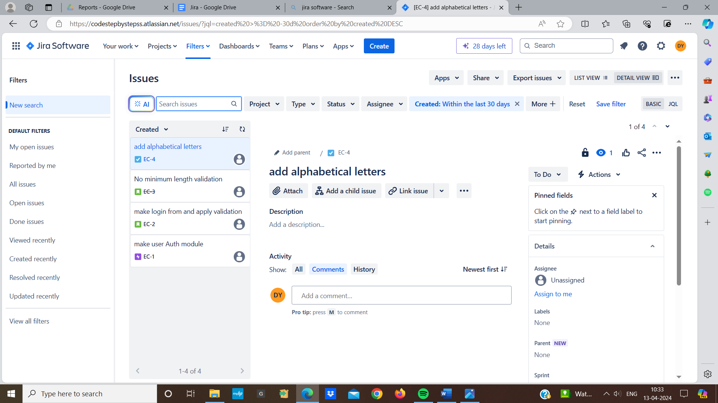

**Advanced issue search:**

* Jira also has a advanced search feature
* Which allows us to perform detailed searches using jira query language (JQL)
* We can specify multiple , terms with logical operators and use functions to search their results

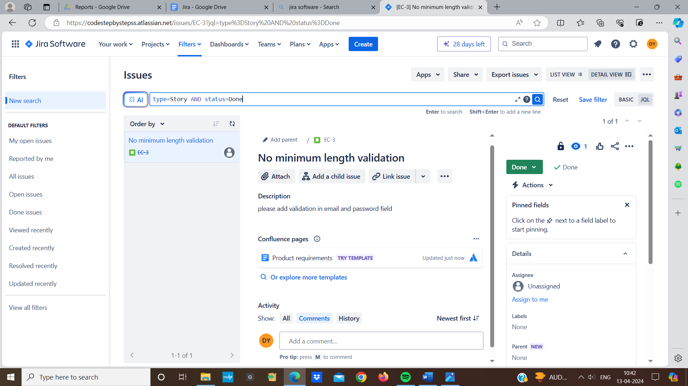

* **Add new issue type:**

**Comman default issue type across the jira projects are:**

1. Tasks
2. Story
3. Bug
4. Epic
5. Sub- task

**To add a new issue type in jira**

1. In jira under issues select “Issue type”
2. Click on “create issue type” enter the name and description for new issue type and specify the icon for the new issue type
3. Then click on create button
4. Once the new issue type is added it will be available for use in jira project

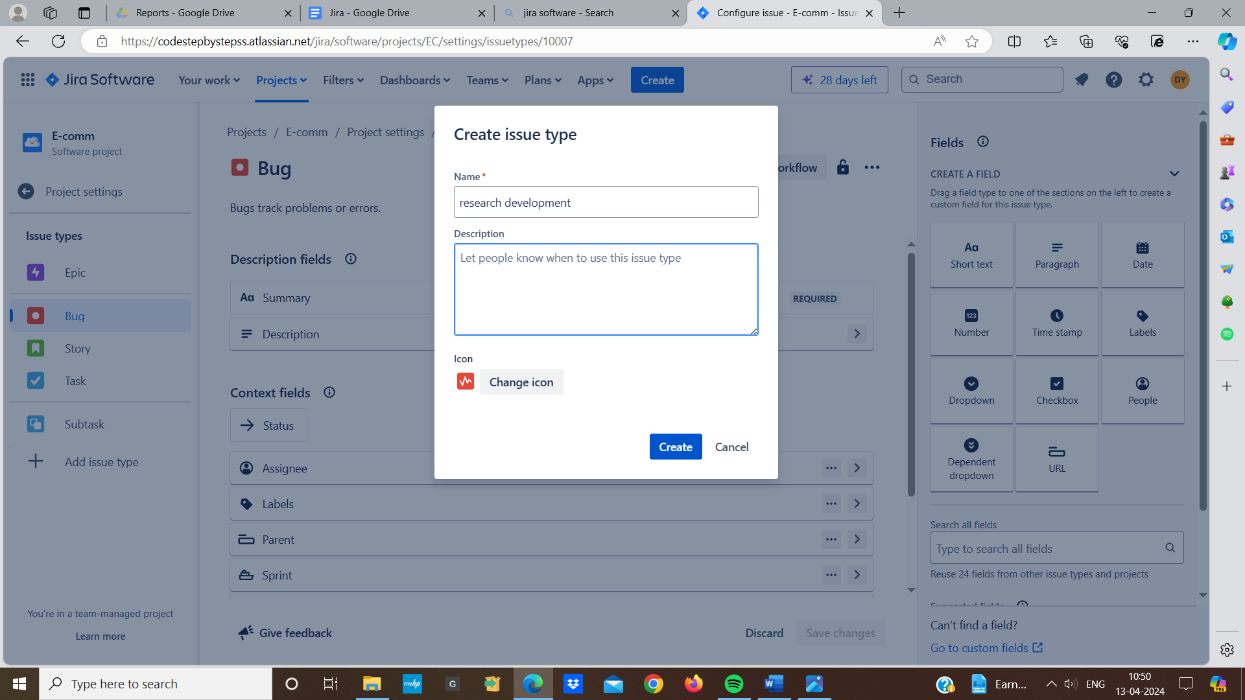

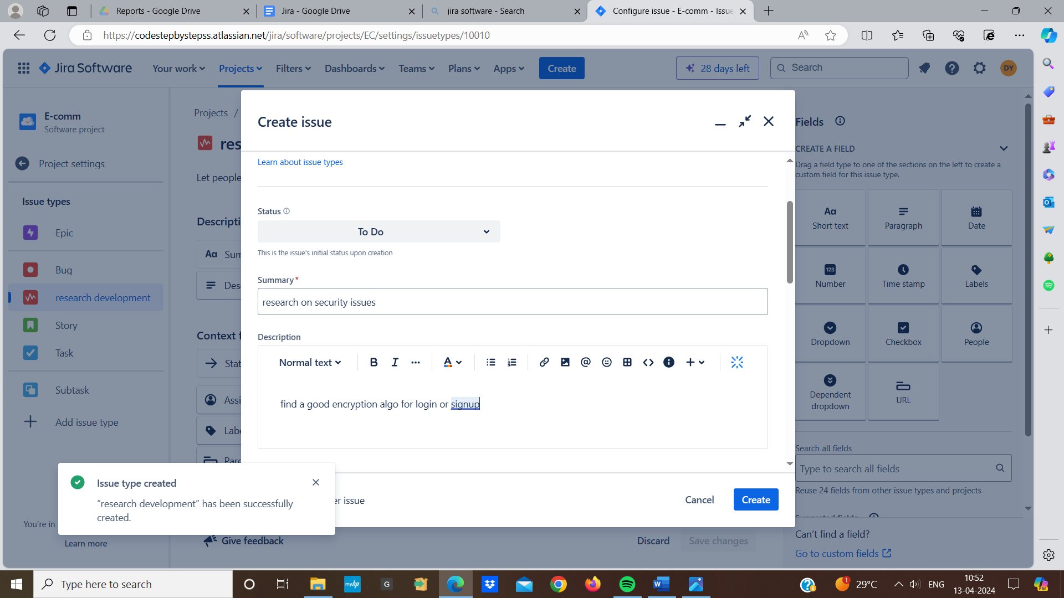

* **Labels in jira:**

Labels are used as tags that can be added to issues for

making them easier to search or find. Labels can be useful for quickly identifying attributes, categories

**Adding labels to issues:**

* First we open the issue where we want to add label in the issue we will see “Label” field then click on the “Labels” field and we can type the name of the label
* Press enter to add the label we can add multiple labels to a single issue

**Searching for issue with labels:**

* To find all issues with specific label we can use basic search bar
* Type the label name and it will show suggestions
* Also we can use advanced search feature with JQL to find the issues with labels

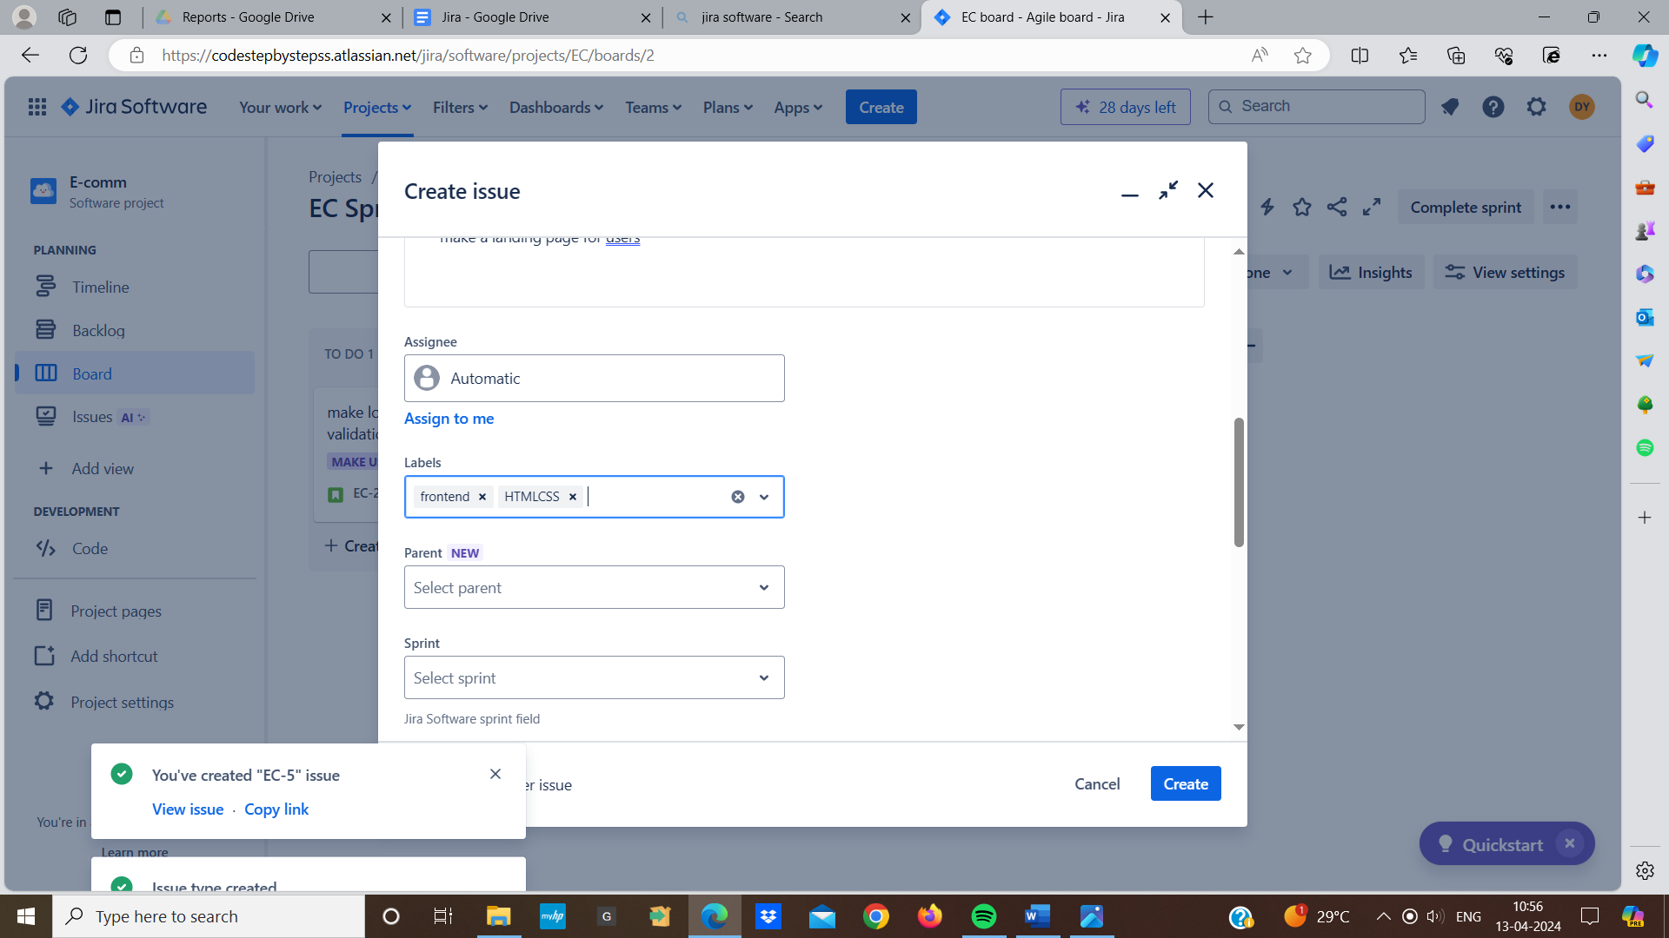

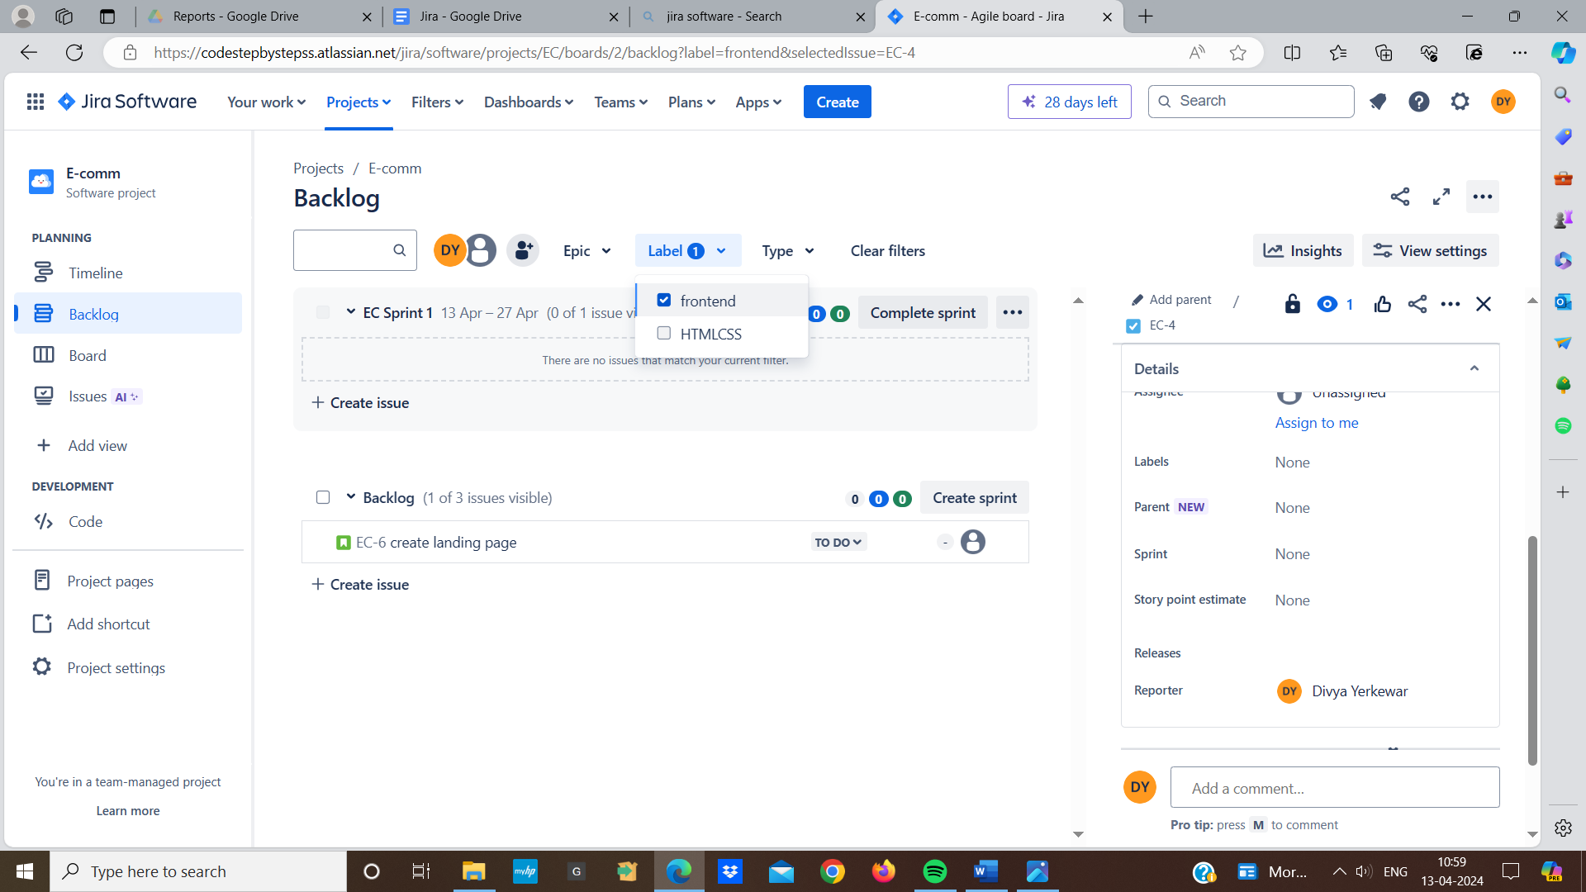

* **Connect jira with git:**
* In jira go to the “Code” option and the tools comes (e.g github for jira , bitbucket cloud for jira) we install github once the installed this will require us to log in to our git then we will connect our git repository
* We need to set up permission to ensure that the team members who need to create branches or execute tests

**Create branches from jira**

* First we ensure that jira shows information of git on the project issues
* Go to the jira issue and click on the “create branch” this will allows us to select repository and enter the branch name and branch from fields
* Then we use tools like jenkins that automatically tests our code

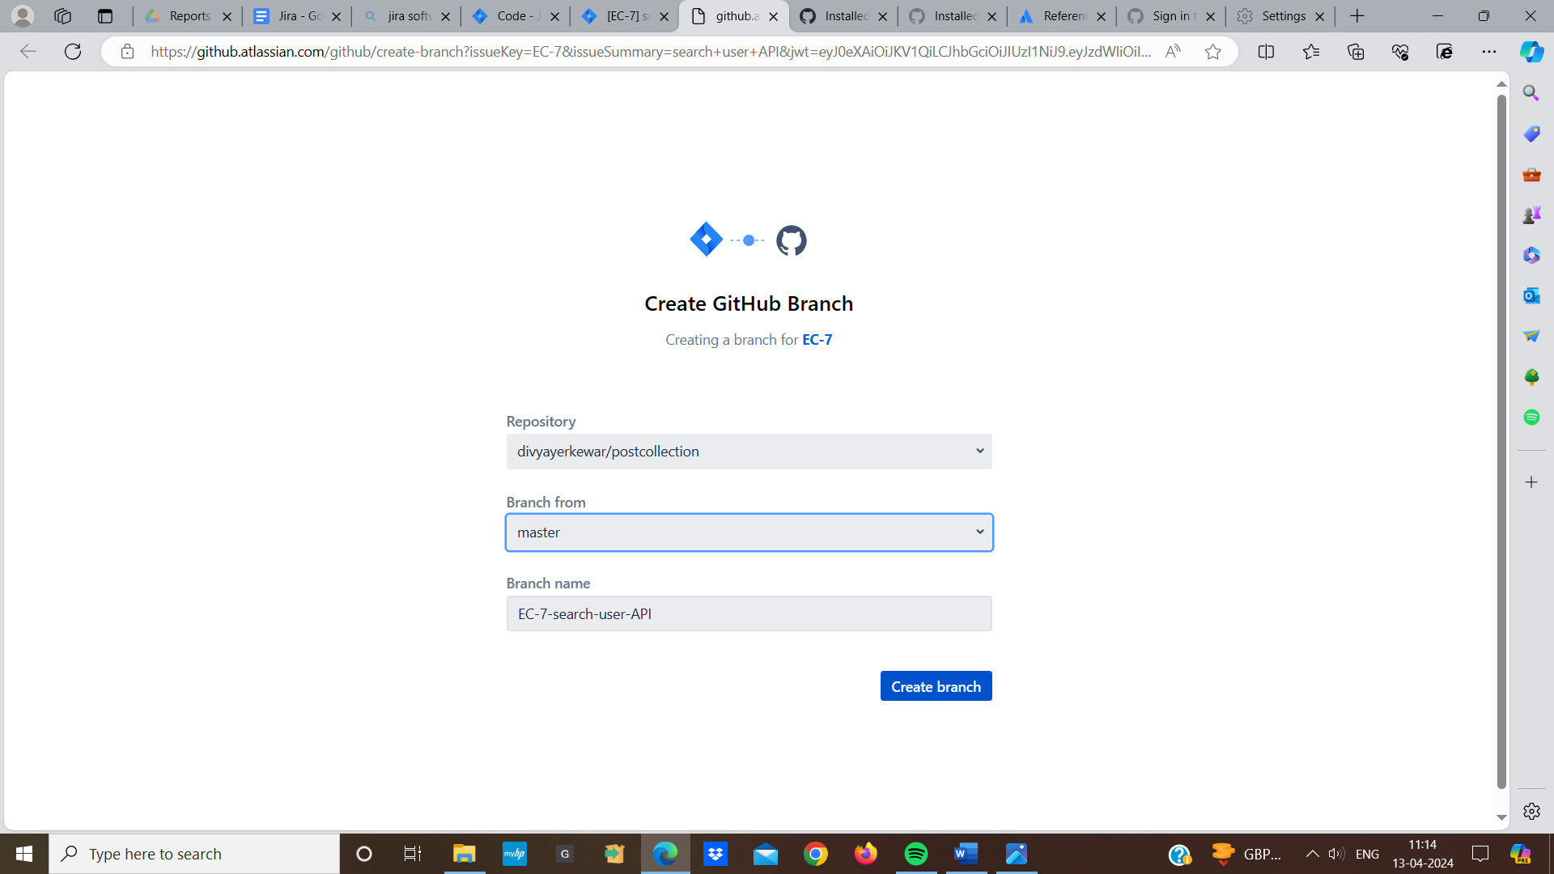

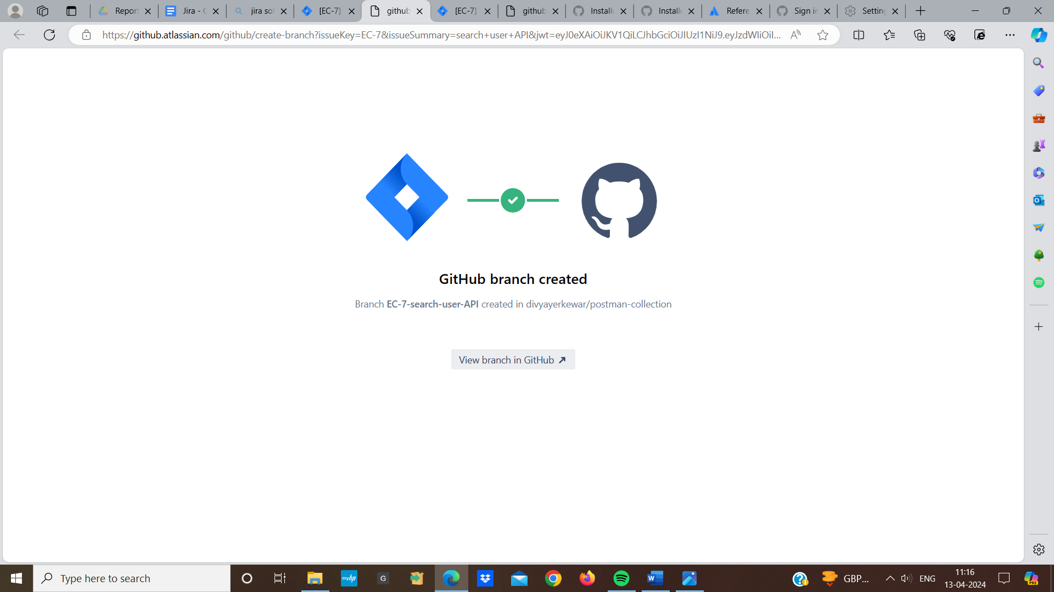

* **Dashboard:**

Dashboard is a customize area where we can add gadgets to show different information about our project like task progress,charts and summaries

**Create a dashboard:**

* First we go to the dashboard and select the create new dashboard and we give our dashboard name and a brief description
* We can also decide whether this dashboard is private or shared with others

**Add gadgets to our project:**

* Go to our new dashboard and click on “Add gadget”
* We can preview a gadget by clicking on it this will show us what data it display
* Click “Add gadget” after selecting the one we want then it will appear on our dashboard

**Options with dashboard:**

* We can drag and drop gadgets to arrange them
* We can also edit or delete gadgets
* We can also decide who can see or edit our dashboard

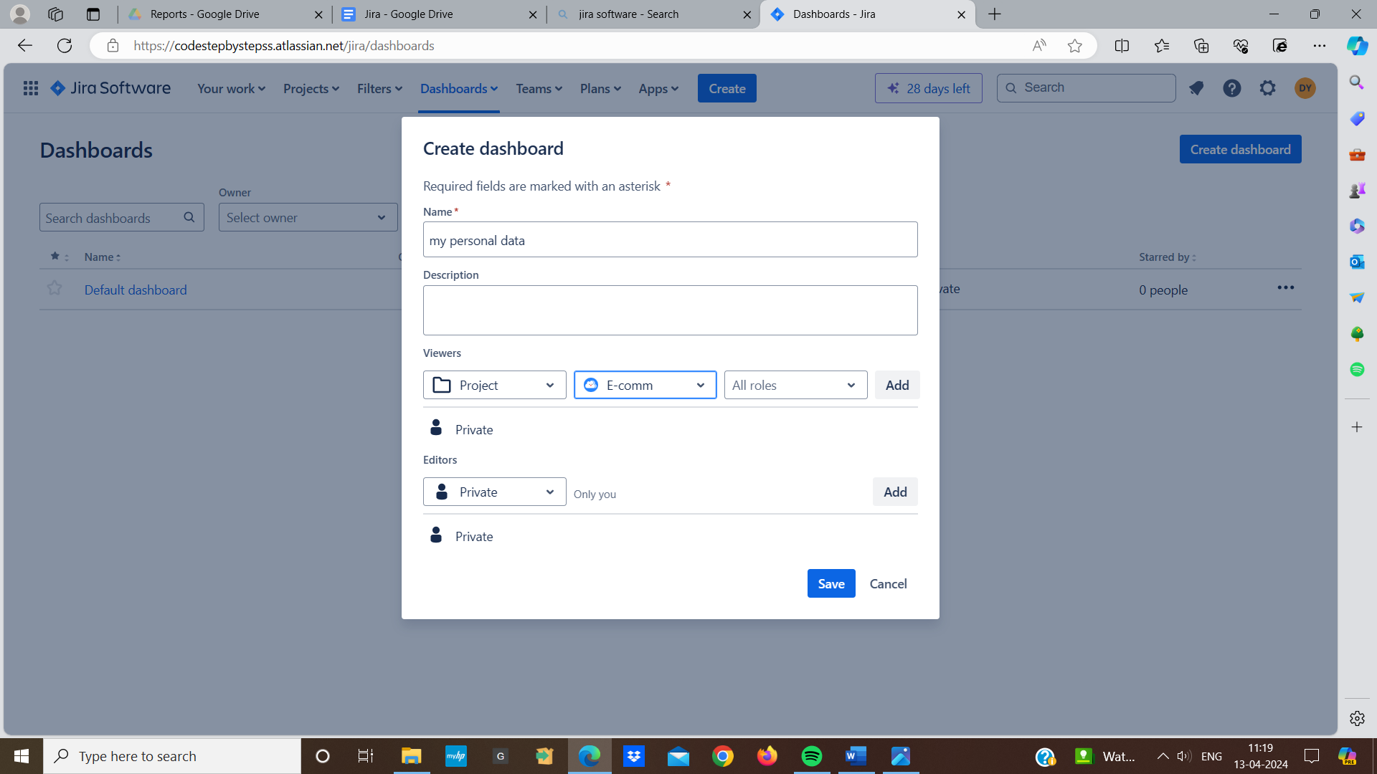

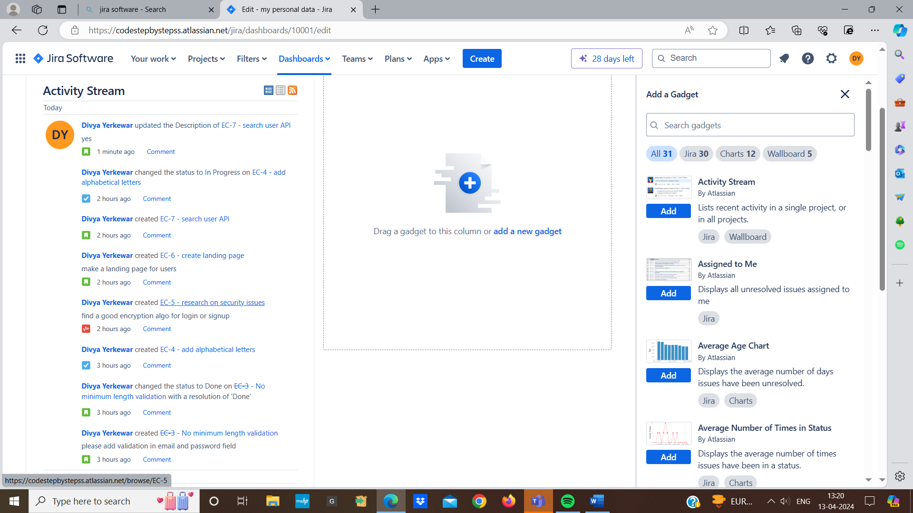

* **Issue template:**

Issue template is not standard feature we can customize it by adding, removing or creating a particular type of issue

**Adding custom fields:**

* Under issue in the setting field we will see custom field option and choose the kind of field we need like text and date set it up and add it to the screen
* We can also remove the custom field from an issue type or also edit it

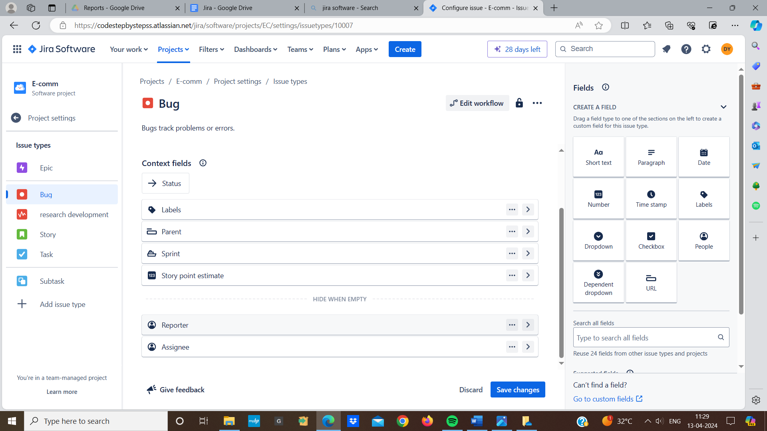

* **Workflow:**
* Workflow is like a roadmap in that an issue moves from start to end each status represents a stage in the progress such as “To-Do”, “In progress”, “Done”
* Assignee person are responsible for the issue at any given steps
* Jira comes with default workflow and stages but we can customized it
* Comman default stages include “To-Do”, “In progress”, “Done”

**Adding workflow status:**

* First we got to jira setting and click on workflow option and select the workflow we want to edit
* We can also add new status

**Adding rules for workflow:**

* We can also define criteria that must be met for a transition like certain fields being filled out
* We can specify requirements that must be satisfied before a transition can

be complete

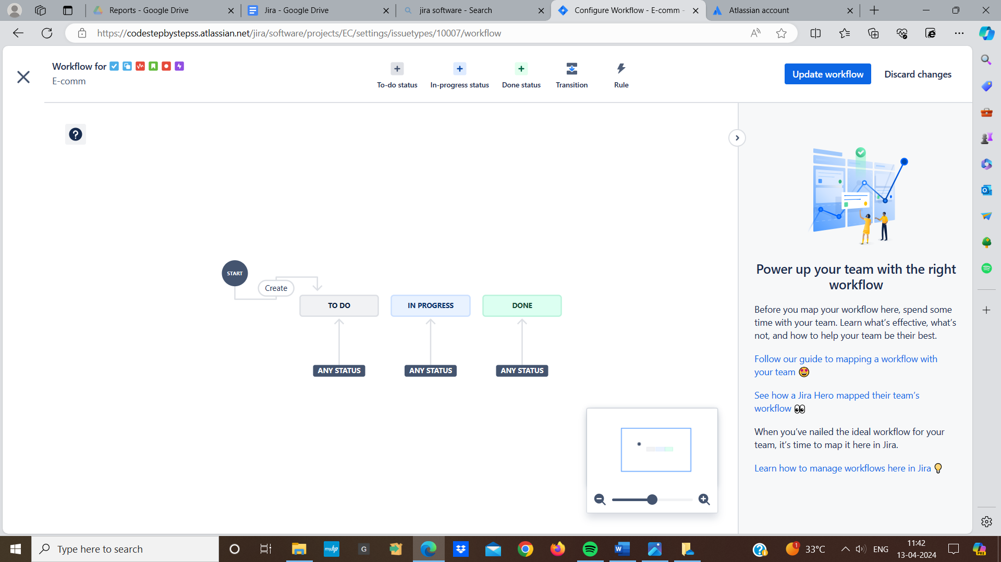

* **Enabling features:**
* Enabling features means turning on certain functions that are available but not enable
* We might turn on feature like task board or custom workflowin jira to help manage our project
* To enable feature we go to project setting in the features options we set up features we want to use within projects
* And save our changes to apply the enabled features to our project

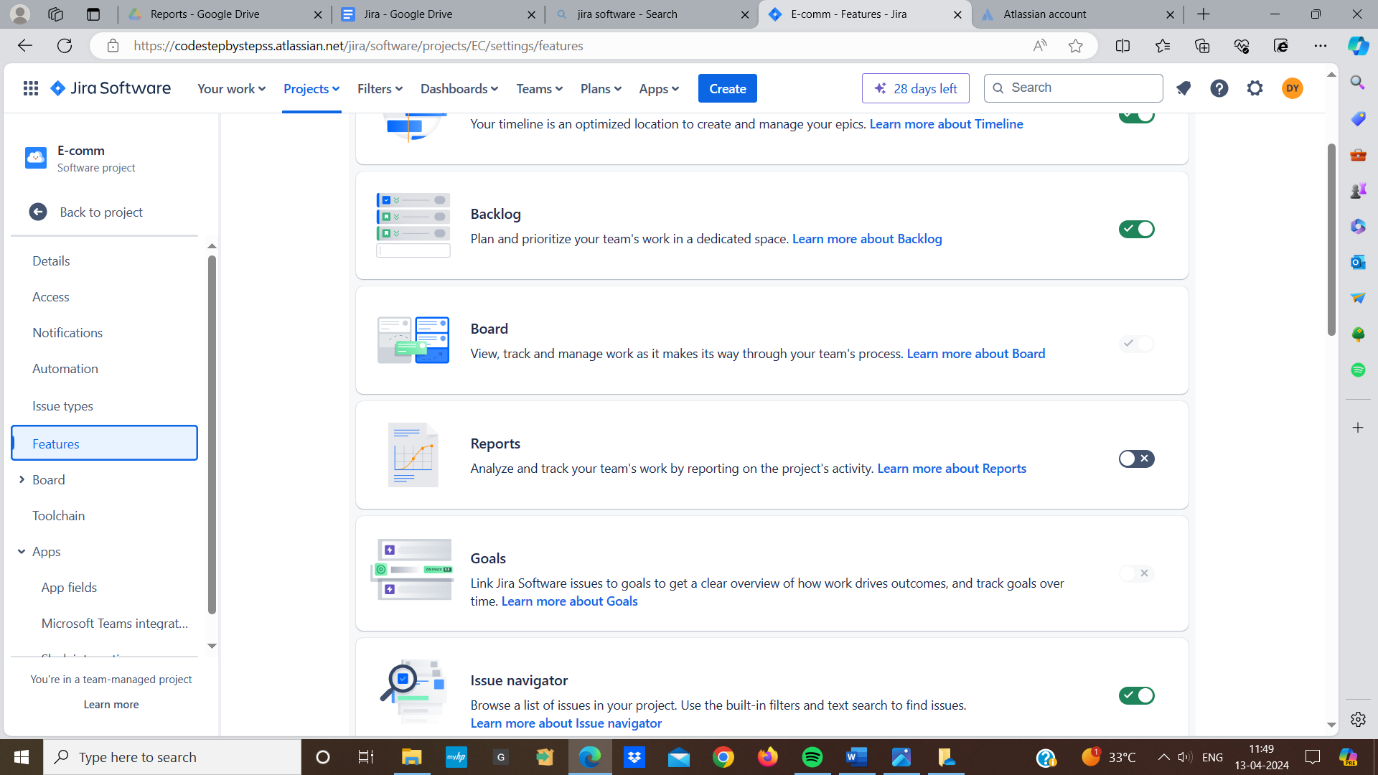

* **Issue activity and activity stream:**

**Issue activity :**

In jira an issue activity means any actions that happen to an issue like when it's updated, created,or commented on. The issue's activity history captures these events.

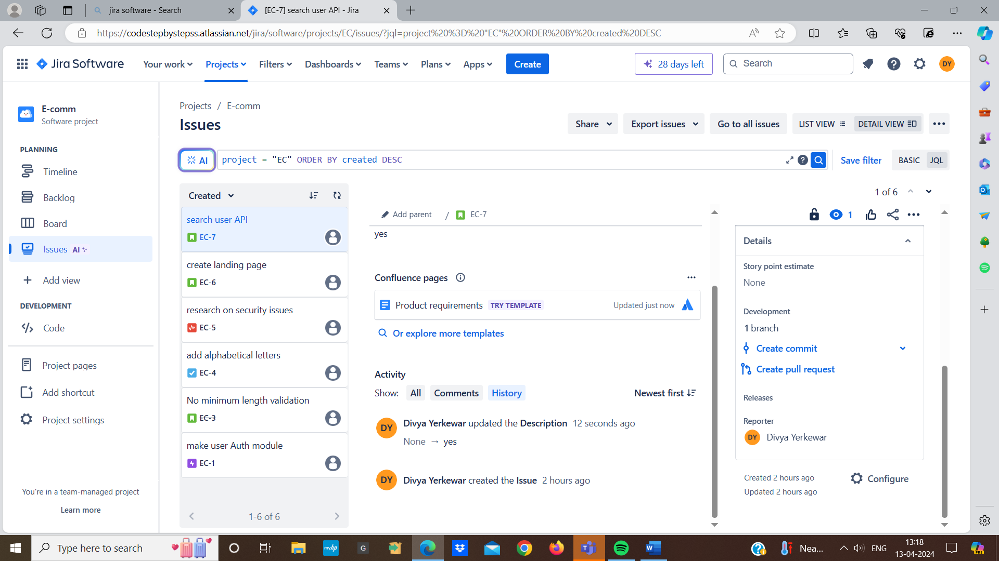

**Activity stream:**

An activity stream shows a summary of recent activities across multiple projects or issues helping us to stay up to date. It provides a view of what's happening in jira



* **Charts and reports in jira:**

In jira charts are visual representation of our projects data that help us to understand the progress

**Use of charts:**

* Charts helps us to track the progress such as sprint progress, issue status
* Charts provides a graphical representation of project to make it easier to understand
* Charts highlights the data allowing team to identify areas for improvements

**How to see reports in jira:**

* In jira we can access reports by clicking on the reports option in the project setting
* Select the type of report we want to view such as sprint report, burndown chart, burnup chart, velocity chart
* We filter the charts by choosing the data what data we want to see
* Once we have setup everything the chart will show us the information we need

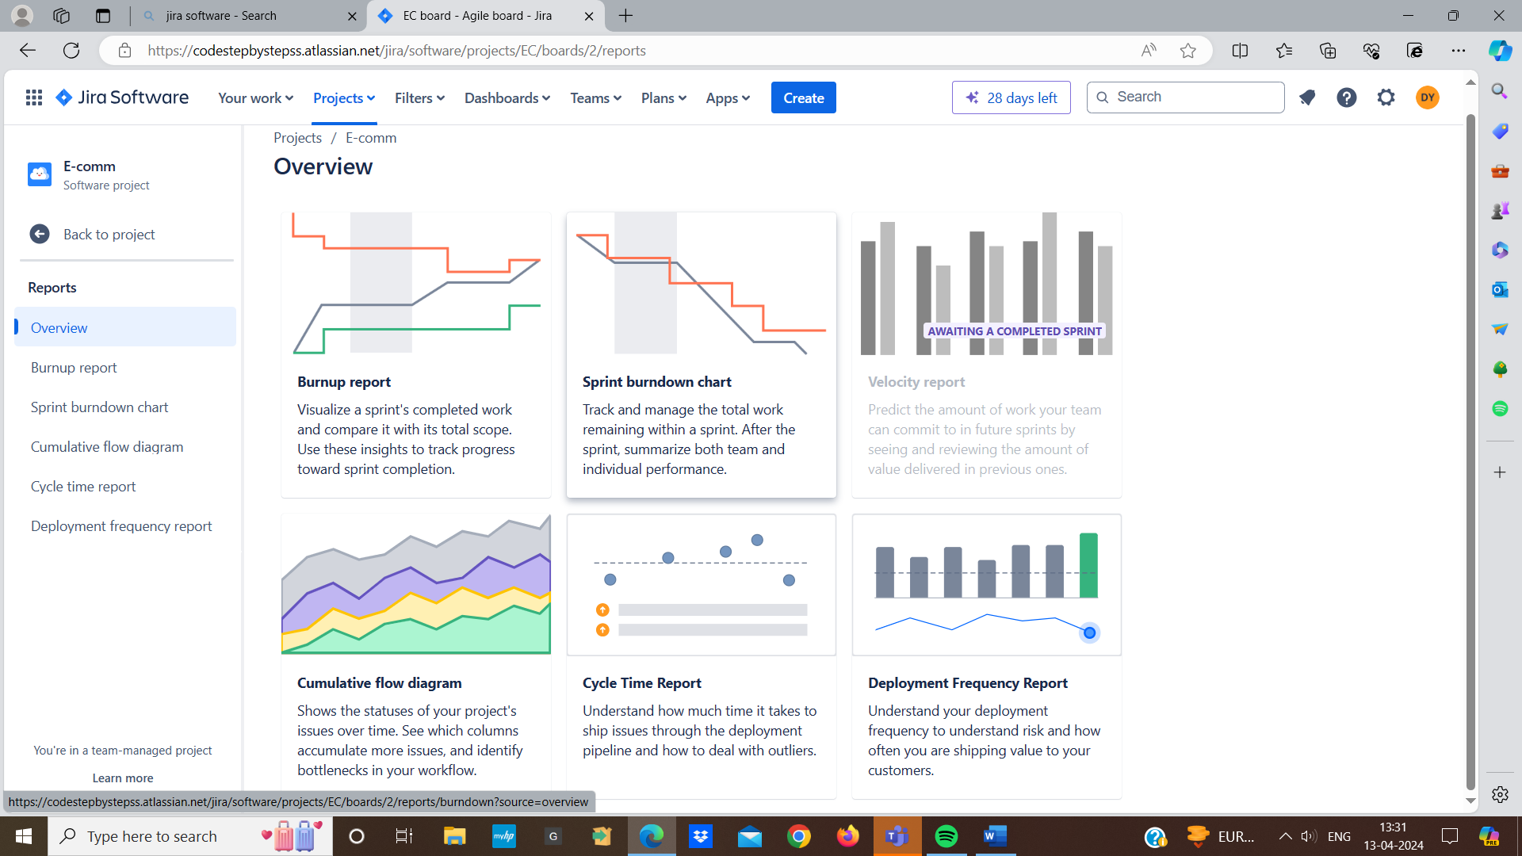

* **Sprint burndown charts:**
* Burndown charts shows how much work our team has left to do
* It helps us to see if our team is completing tasks on time
* It has graph that shows the amount of work remaining in the sprint
* There is a straight line that shows how much work team should completed each day
* The team progress line should be close to the ideal line means showing consistent progress each day
* If there should not be big drops in the progress line means indicated issues in the sprints
* By the end of the sprint the progress line should reach zero means all work is completed

**How to access a burndown chart:**

* Go to the “Reports” section in our jira project
* Choose the burndown chart and pick the sprint we want to see the progress
* The chart will shows us how our team is doing and the actual progress
* **Sprint burnup charts:**
* Burnup chart is used to track the progress of work completed and total scope
* Burnup chart display both completed work and the total amount of work for a sprint
* It provides a clear representation of how much work has been completed compared to the original work
* If the completed work line should increase over time showing progress towards completing the total work
* If the completed work line intersect with the total scope line by the end of the sprint indicating that all work has been completed
* **Velocity report :**
* Velocity helps us to measure how much work we can complete in a particular sprint
* Velocity tracks the amount of work in story points
* The report will shows bar representing the amount of work completed in each sprint
* The report includes an average line that indicates the average amount of work completed per sprint
* **Cycle time and deployment frequency:**

**Cycle time:**

* Cycle time measures the amount of time taken for our team to complete work from start to finish
* In that includes everything from when work start on a task until our task is completed
* Cycle time helps us to identify where delay occurs in the workflow

**Deployment frequency:**

* Deployment frequency tracks how frequently our team successfully release a new version of the software
* We keep track of every time we release a new update to our software
* We can check this every day, or months